Facilitator’s Summary of Observations from WPTF Pre-Meeting Survey
May 2025

Respondents

All 11 voting TF members responded. None of the non-voting members chose to respond.

Criteria weights

Question: Please allocate 15 points across the 5 criteria by entering a number into each of the boxes below, corresponding to the relative importance or relevance of that criterion for you in evaluating the options for this project.

Responses:
- Overall, wide range of perspectives/weightings and rationales
- Some patterns
  - Ecological and fiscal sustainability are both weighted somewhat higher on average
  - Mobility & accessibility is weighted somewhat lower on average

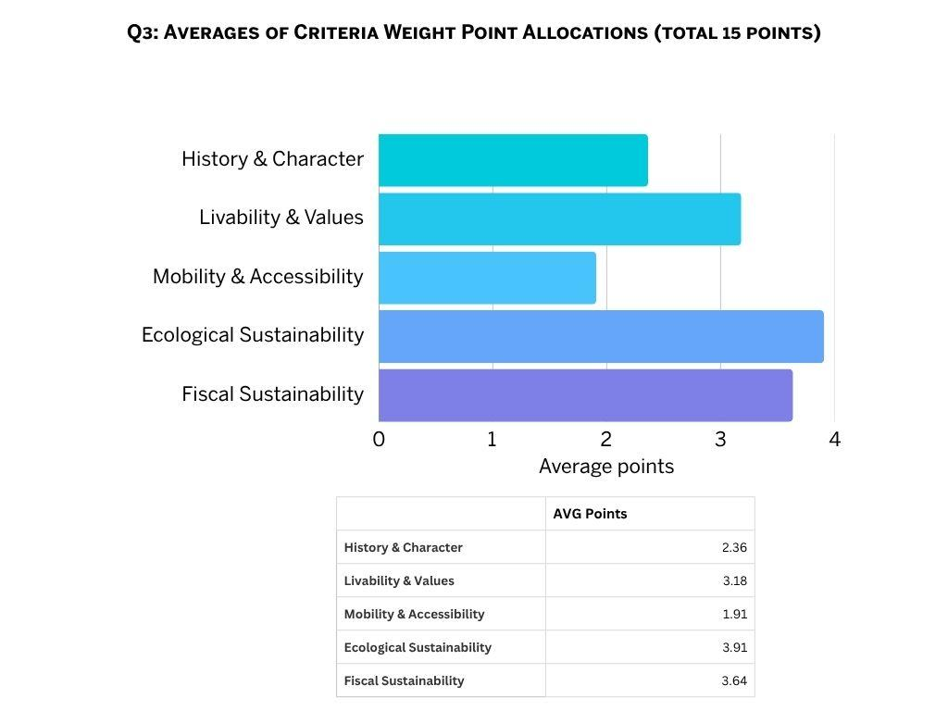

Proposal ratings against criteria

Question: Please rate the proposals against each of our five high-level criteria on a scale from 1-5.

Responses
- Wide range of ratings and explanations across the proposals and criteria
- Few areas of clear alignment
- No single proposal stands out with respect to its average ratings
- Some noteworthy averages:
  - Recurring management:
    - Highest average rating on fiscal responsibility
    - Lowest average rating on ecological sustainability
  - Dam removal:
    - Highest average rating on ecological sustainability
    - Lowest average ratings on history & character, livability & values, and mobility & accessibility
  - Dredging Alternative C (100k cy)
    - Highest average ratings on history & character, livability & values, and mobility & accessibility
    - Lowest average rating on fiscal sustainability
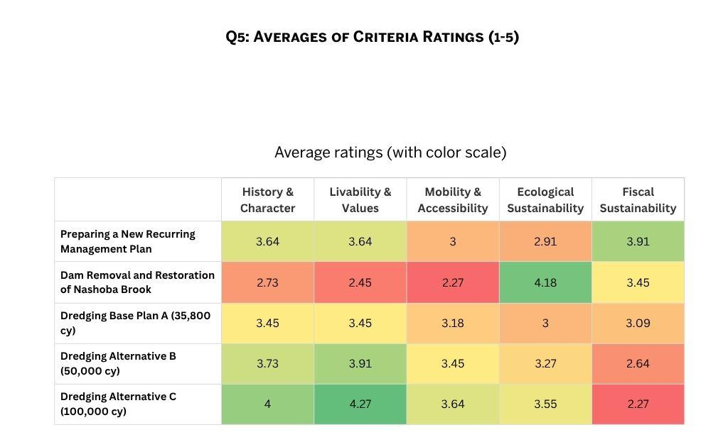

Ordered rankings of the 5 proposals

Question: Please reflect on your answers above and share your overall ordered ranking of the five proposals.

Responses
- There is broad support/acceptance for the recurring management proposal, including among members who have very different preferences overall, though with some exceptions.
  - Many members suggest it is the only pathway likely to garner consensus, and note that it could allow for either dredging or dam removal in the future.
  - At least 2 members have strong concerns about it due to skepticism it will have a positive impact and a sense of urgency around addressing issues in the pond and achieving our TF mission.
  - Recurring Management rankings
    - 7 first place votes
    - 2 second place votes
    - 2 last place votes
- There is a significant divide in the group on dam removal.
  - Members have a wide range of perspectives on its impacts, costs, benefits, and uncertainties.
  - Some strong concerns focusing on its irreversibility.
  - Dam Removal rankings
    - 4 first place votes
    - 1 second and 1 third place vote
    - 5 last place votes
- The group is also split around dredging.
  - Those who may support it over the long term prefer we start with recurring management options.
  - Looking only at each member’s most-preferred dredge size (and ignoring their rankings for whichever 2 dredge alternatives they ranked lower) vs. recurring management & dam removal, we see:
    - 0 first place votes for each member’s most-preferred dredge size (vs. recurring management & dam removal)
    - 8 second place votes
    - 3 third/last place votes
- There are a range of perspectives on the most-preferred dredge size, mostly based on how people weight fiscal vs. ecological and recreational concerns
  - Looking only at how each member ranked the three dredging alternatives against each other (and ignoring the other 2 proposals), we see
    - Alternative A (36k cy)
      - 5 members’ most preferred dredge option
      - 1 member’s middle preferred dredge option
      - 5 members’ least preferred dredge option
    - Alternative B (50k cy)
      - 3 members’ most preferred dredge option
      - 8 members’ middle preferred dredge option
      - 0 members’ least preferred dredge option
    - Alternative C (100k cy)
      - 3 members’ most preferred dredge option
      - 2 members’ middle preferred dredge option
      - 6 members’ least preferred dredge option

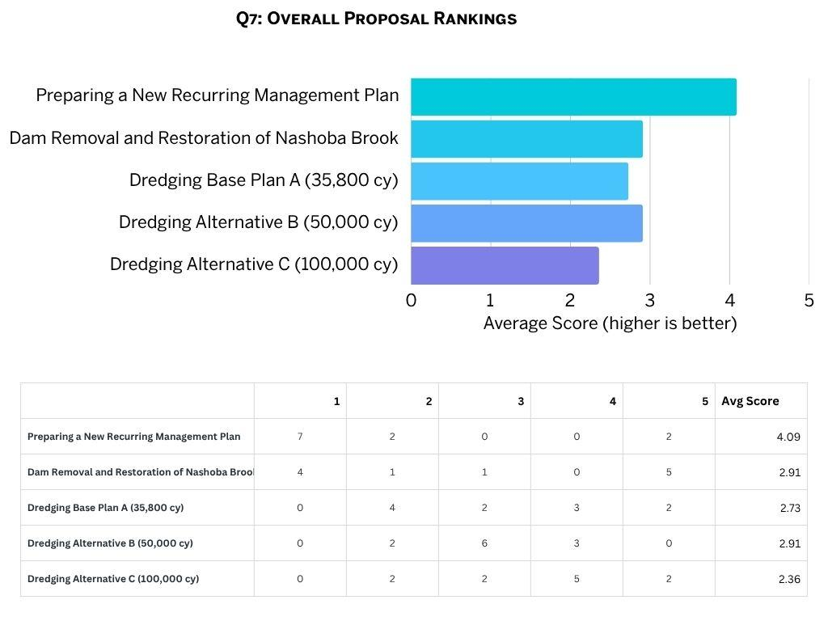

Ideas for consensus

Question: What are some pathways/recommendations that you think could garner consensus within the Task Force?

Responses
- No members suggested the dam removal proposal or any of the three dredging proposals as pathways to consensus.
- Some members offered multiple suggestions.
- Various members suggested consensus could be achieved by moving forward with a version of the recurring management proposal. Specific recommendations included:
  - NRC establishes WP Watershed Management Committee to prepare recurring and adaptive management strategy
  - Mandate/implementation should be serious/rigorous: Town funding, prioritization, goal setting
  - Committee could propose dredging, fish passage, or a better drawdown mechanism, and propose additional feasibility studies. Dam removal would also remain an option.
  - There is support from a dedicated pond manager and/or management firm
  - Funded through re-application to the CPC
  - Minimum 5-year commitment, then potential reevaluation
  - In the future, the Committee could develop a more informed long-term plan, with more stakeholder input and town consensus, around dam removal and/or dredging.
  - Along with a recommendation for recurring management in the short-term, the TF could consider if there is consensus or directional agreement on recommendations across longer-term time frames as well.
- Some members suggested a version of dam removal plus dredging to deepen/expand the deep hole
  - E.g., the deep hole could be expanded to 10-15 acres, with adequate depth to limit the spread of aquatic invasives
- Several members suggested recommending various ideas that could/should be implemented regardless of the broader plan. Specifically:
  - Boat launch/public access/parking improvements along Comm Ave.
  - Similar improvements at Pond St. and/or the current dam location
  - Water access and improved viewing from Gerow
  - Trails (e.g., around ag field and bridge crossing Nashoba Brook near BFRT)
  - Rt. 2 stormwater mgmt
  - Historical panels in the pocket park
  - Monitoring how the pond is used
  - Recommendations for a pathway forward over time, with different suggestions over different time frames

